**CHAPTER II  
BASIC OF THEORY**

**II.1 Definition of Barcode**

Barcode is an optical machine-readable representation of data relating to the object to which it’s attached. Barcode can be described as an optical Morse code. It’s the small image of lines (bars) and spaces that is affixed to identification the information. Barcodes originally were scanned by special optical scanners called barcode readers. The code uses a sequence of vertical bars and spaces to represent number and other symbols are read with a scanner that turned into a line of text for user device, which measures reflected light and interprets the code into numbers and letters that are passed on to a device­.

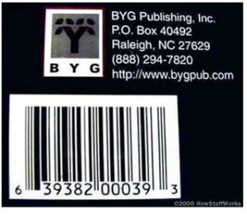

**Figure 2.1 Example Linear Barcode from some product (REF: http://bygpub.com / )**

A barcode essentially is a way to encode information in visual pattern that a machine can read the combination of white and black bars represents different text character which follows a set algorithm for that barcode type, if users change the sequence of bars, user will get the different of text from that barcode. Originally barcodes systematically represented data by varying width and spacing of parallel lines and may be referred to linear barcode (1D) and then evolved into rectangles, dots, hexagons and other geometric patterns barcode (2D) and now is 3 Dimension barcode. Barcode symbol typically consist of five parts is a quiet zone, a start character, data characters, a stop character and another quiet zone. Barcode can hold any type of text information that user encode but with the product labels the price in not usually encoded.

### II.2 History of Barcode

It all started in 1949 on a beach when Joseph Woodland, a mechanical engineer at Drexel University, drew a set of parallel lines in the sand that “represented a kind of ‘long form’ of dots and dashes” or Morse code. Woodland had been thinking about the ways Morse code might be used to solve a problem his colleague Bernard Silver had presented to him. Months earlier, Silver had overheard the president of a grocery chain appeal to the dean of Drexel University to help him devise a system to automate the grocery checkout process.

On October 20, 1949, Woodland and Silver filed a patent application for a “Classifying Apparatus and Method” — the first barcode concept. They finally received their patent in October 1952, and while the idea was intriguing to a number of companies and industries, the scanning technology, which would eventually allow the barcode to become one of the most ubiquitous symbols in the world did not yet exist. In the 1950s and 1960s various companies and industries tried to develop the barcode technology.

The first implementation was the KarTrak system developed by David Collins for the Boston and Maine Railroad company. It was subsequently selected as the standard by the Association of American Railroads (AAR) and by 1974, 95% of the AAR fleet was labeled with the KarTrak system. However, the system was never fully functional and its use was discontinued by the late 1970s. The breakthrough that would lead to the global spread of barcodes was the development of the Universal Product Code (UPC). In 1966 the National Association of Food Chains (NAFC) began to discuss the idea of automated checkout systems.

At the time, RCA owned the rights to Woodland and Silver’s original patent and began an internal project to develop an effective system. Then, in the mid-1970s, the NAFC established the U.S. Supermarket Ad Hoc Committee on a Uniform Grocery Product Code, to create basic guidelines for barcode development and an effective coding system. This led to the creation of a standardized 11-digit code to identify any product. At the time, IBM employed George Lauer and had him begin work on what would become the standard UPC linear 1D barcode. The critical moment came in 1974 on June 26th when the first barcode was scanned in a supermarket in Troy, Ohio. It was a 10-pack of Wrigley’s Juicy Fruit gum. Over time the barcode has expanded from simple lines to complicated designs and helps people track everything from a can of soda to top secret assets in the Department of Defense.

### II.3 Definition of Linear Barcode

Linear Barcode is the first generation of barcode or can be called One Dimensional Barcode, Linear Barcode is typical “Picket Fence” style barcode is made up of lines and spaces of various widths that create specific patterns that represent Stock-Keeping Unit (SKU) numbers which are easily and quickly read by barcode scanners, all information in the barcode are organized horizontally from the left to the right of code except from the bottom to the upper of code, it’s not contain any information.

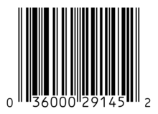

**Figure 2.2 Linear Barcode Example Code** **(REF:** [**http://en.wikipedia.org/wiki/Barcode**](http://en.wikipedia.org/wiki/Barcode)**)**

Linear Barcode, the information inside the code is linearly, encoded with intervals of alternating diffuse reflectivity (highs and lows signal-wise), usually black and white in color. Interval are actually stored as rectangles whose vertical height carry no information but facilitates the scanning process and electronically corresponds to the actual bars and spaces of the symbol.

Linear Barcode have variety of symbologies (barcode) type, these symbologies work in the same way, although different symbologiest of Linear Barcode may change the appearance of the letter, the information include that barcode will never be effected. Linear codes, in which character are grouped one next to another character in one linear direction. Simply, put a single row of parallel bars and spaces, only width of bars and sometimes spaces are measured to interpret the symbol. The height of the code is simply redundancy to enable scanners to more easily scan the symbol.

### II.4 Types and Uses For Of Linear Barcode

|  |  |  |
| --- | --- | --- |
| **SYMBOLOGY** | **MAPPED** | **USES** |
| Code bar | Discrete | Old Format Used In Libraries And Blood Banks. |
| Code  25 – Non-interleaved 2 of 5 | Continuous | Industrial |
| Code 25 – Interleaved 2 of 5 | Continuous | Wholesale, libraries International standard ISO/IEC 16390 |
| Code 11 | Discrete | Telephones (out of date) |
| Code 39 | Discrete | Various – international standard ISO/IEC 16388 |
| Code 49 | Continuous | Various |
| Code 93 | Continuous | Various |
| Code 128 | Continuous | Various – International Standard ISO/IEC 15417 |
| CPC Binary | Discrete |  |
| DX film edge barcode | Neither | Color print film |
| EAN 2 | Continuous | add on code (magazines), GS1-approved – not an own symbology – to be used only with an EAN/UPC according to ISO/IEC 15420 |
| EAN 5 | Continuous | Add on code (books), GS1-approved – not an own symbology – to be used only with an EAN/UPC according to ISO/IEC 15420 |
| EAN-8, EAN-13 | Continuous | Worldwide retail, GS1-approved – International Standard ISO/IEC 15420 |
| Facing Identification Mark | Discrete | USPS business reply mail |

|  |  |  |
| --- | --- | --- |
| GS1-128 (formerly named UCC/EAN-128), incorrectly referenced as EAN 128 and UCC 128 | Continuous | Various, GS1-approved -is just an application of the Code 128 (ISO/IEC 15417) using the ANS MH10.8.2 AI Data structures. It’s not an own symbology. |
| GS1 DataBar, formerly Reduced Space Symbology  (RSS) | Continuous | Various, GS1-approved |
| Intelligent Mail barcode | Discrete | United States Postal Service, replaces both POSTNET and PLANET symbols (formerly named One Code) |
| ITF-14 | Continuous | Non-retail packaging levels, GS1-approved – is just an Interleaved 2/5 Code (ISO/IEC 16390) with a few additional specifications, according to the GS1 General Specifications |
| JAN | Continuous | Used in Japan, similar and compatible with EAN-13 (ISO/IEC 15420) |
| KarTrak ACI | Discrete | Used in North America on railroad rolling equipment |
| MSI | Continuous | Used for warehouse shelves and inventory |
| Pharmacode | Discrete | Pharmaceutical packaging (no international standard available) |
| PLANET | Continuous | United States Postal Service (no international standard available) |
| Plessey | Continuous | Catalogs, store shelves, inventory (no international standard available) |
| PostBar | Discrete | Canadian Post office |
| POSTNET | Discrete | United States Postal Service (no international standard available) |
| RM4SCC / KIX | Discrete | Royal Mail / Royal TPG Post |
| Telepen | Continuous | Libraries (UK) |
| Universal Product Code (U.P.C.) | Continuous | Worldwide retail, GS1-approved – International Standard ISO/IEC 15420 |

**Table 2.1 Types And Uses For Of Linear Barcode**

### II.5 The Architecture of Linear Barcode

Linear barcode have a structure like a quite zone before the start character and after stop character, start character and stop character, Intercharacter gap (only used in discrete codes) and Data Character. Linear barcode is built with single row of parallel bars and spaces of varying widths that represent data. Linear barcode only have 20-25 character in the code. The data in linear barcode only read horizontally.

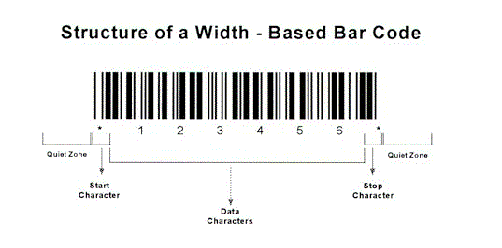

**Figure 2.3 Architecture Based Linear Barcode (REF:** [**www.detaid.com/whatisbarcode.htm**](www.detaid.com/whatisbarcode.htm)**)**

Scan rates scanner barcode of 100 scans per second is commonly and will be offer up to 800 scans per second. If the color of barcode absolutely solid, its can more be easily to be scanned with scanner. Not only the solid color, the distance of the scanner to scan the barcode important too. Long-range Linear Imagers can read out to 2 inch (40mm or 50mm), while its extended, that can lead up to 18 inch (460mm). Close Range scanning its uses for small barcode, and Long Range scanning its use for the large barcode.

Important to know where the scan line is as the reading distance is increases. Laser scanners, its clearly marked by the laser line but linear imagers depend on the illumination of the LEDs, as the result it will became more difficult to seeing as the reading distance increase or in high ambient light conditions such as the direct of sunlight.

Basic linear structure for the barcode words, representing each digit by unique pattern of bars and spaces with varying width that will be one, two, three or four modules wide. Total of width for digit is 7 modules. Example, to represent 12 digits of the UPC-A code, that must requires a total of 7 modules of total width then multiply with 12 digits of the UPC-A code, so the total modules of UPC-A code is 84 modules but the complete UPC-A is 95 modules, 84 module for the digit Left Pattern and Right Pattern that combined with 11 modules for the Start Pattern, Middle Pattern and End Pattern.

[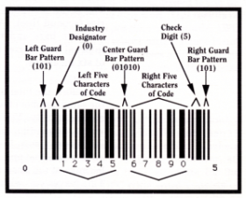](http://www.scholarpedia.org/article/File:Fig_2_Swartz_bar_code.png)

**Figure 2.4 Basic Architecture Linear Barcode** **(REF:** [**http://www.scholarpedia.org/article/Bar_code_scanning**](http://www.scholarpedia.org/article/Bar_code_scanning)**)**

Start Pattern and End Pattern are 3 modules wide and use the pattern Bar-Space-Bar (1-0-1) which each bar and space is one module wide. Middle pattern is 5 module wide and uses the pattern space-bar-space-bar-space (0-1-0-1-0) which each bar and space is one module wide. In UPC Code, Quite Zone (Additional space module) is requires before Start Pattern and after End Pattern.

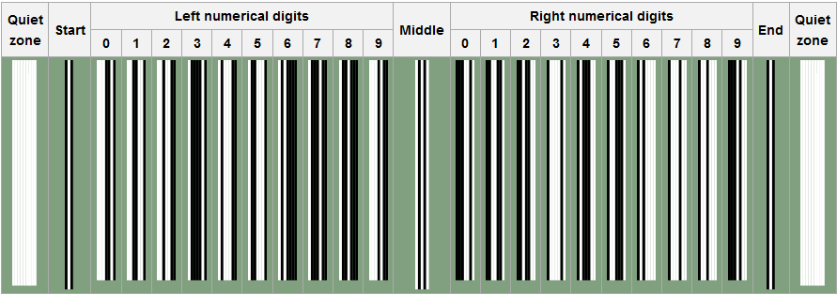

**Figure 2.5 UPC 01 (REF:** [**https://en.wikipedia.org/wiki/Universal_Product_Code**](https://en.wikipedia.org/wiki/Universal_Product_Code)**)**

Example Code 654321. Therefore would be 1-1-1 4-1-1-1 1-2-3-1 2-3-1-1 1-4-1-1 2-2-1-2 2-2-2-1 1-1-1-1-1-1.

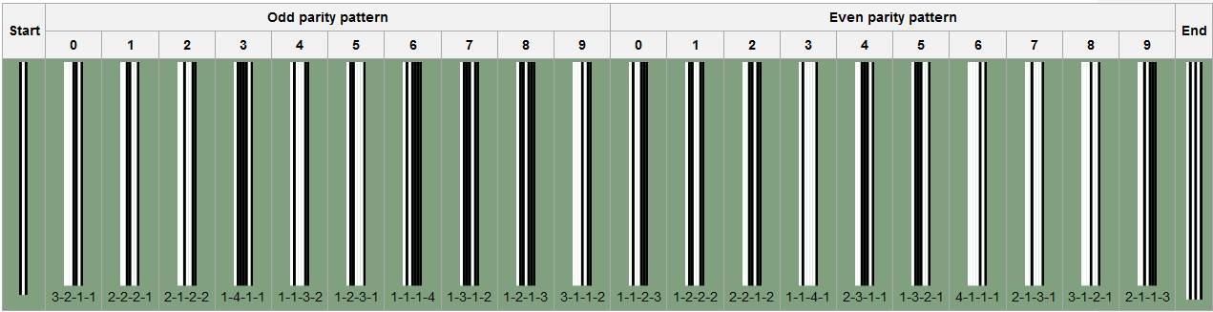

**Figure 2.6 UPC 01 (REF:** [**https://en.wikipedia.org/wiki/Universal_Product_Code**](https://en.wikipedia.org/wiki/Universal_Product_Code)**)**

[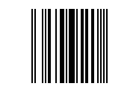](https://en.wikipedia.org/wiki/File:UPC-E-654321.png)The UPC can detect 100 percent of single digit errors and 89 percent of transposition errors. The resulting of barcode example is look like this :

**Figure 2.7 UPC CODE Example (REF:** [**https://en.wikipedia.org/wiki/Universal_Product_Code**](https://en.wikipedia.org/wiki/Universal_Product_Code)**)**

**II.6 Barcode Scanner**

Barcode Scanner / Barcode Reader is a device that decodes the barcode and physically capture information contained in the barcode that consist of the following component which work together to collect, analyze and transmitting data contained in the barcode is :

1. Analyzes data and then sending the content to the scanners output port and a decoder can be internal / external by decoder itself.
2. Scans the barcode image by Lens
3. Illuminate the barcode to make a Light Source
4. Photo conductor will translate optical impulses into electrical ones

Illumination System is the method by which the bars and spaces on the barcode are illuminated. There are variety of illumination systems commonly used in barcode scanner is:

1. Single Point LED

This type of illumination system is exclusive to the barcode wand reader and the barcode slot reader that focused through a single ball-type to touch the barcode while being scanned.

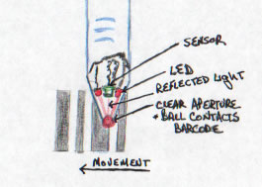

**Figure 2.8 Single Point Led (REF:** [**https://www.carolinabarcode.com/how-barcode-scanners-work-a-69.html**](https://www.carolinabarcode.com/how-barcode-scanners-work-a-69.html)**)**

1. Linear Multiple LED

This type of illumination system is expanding on the single-point illumination system. By placing multiple LED’s in a line that will give an ability to light the entire width of the barcode. Commonly used In CCD scanners and Linear Imagers.

1. Laser

This type of illumination system is the method that uses a single point red laser diode that similar to laser point. Oscillating mirror will expanded the point of light into a line. The distances to scan the barcode are superior from 1mm to 18mm.

1. LED (Light Emitting Diode) Imager

The linear imager and full imager is very similar to CCD device with some important changes like the amount of illumination is increased by using high light LEDs, it will be sense photocells more sensitive mimics both the range and focus of laser scanners. In Full imagers, highly intensity of LED is illuminate a square scanning the target, the light sensors in full imagers very similar to light sensor in monochrome cameras.

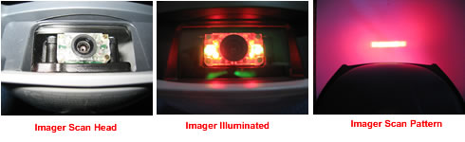

**Figure 2.9 LED’s Imager (REF:**

[**https://www.carolinabarcode.com/how-barcode-scanners-work-a-69.html**](https://www.carolinabarcode.com/how-barcode-scanners-work-a-69.html)**)**

By pairing the target square with sensors that search the target square for a valid barcode, the sensors search the scanning square target for a valid barcode. LED full imager are Omni directional that’s user don't have to line up the barcode in any way in order for it to be decoded.

1. Sensor And Converter

This type of illumination system is uses photo detector sense the reflected light that will generates an analog signal with varying voltage. The voltage fluctuates based on whether the sensor sees the reflected light from the white spaces because the black bars absorb the red light. Commonly used in CCD (Charge Coupled Device) Readers that use an array of hundreds of tiny light sensors lined up in a row in the head of the reader.

Analog signal from photosensor of barcode scanner

**Figure 2.10 Sensor Of Analog Signal (REF:**

[**https://www.carolinabarcode.com/how-barcode-scanners-work-a-69.html**](https://www.carolinabarcode.com/how-barcode-scanners-work-a-69.html)**)**

The sensor in this barcode is built in the lens of scanner. Which each sensor can be thought of as a single photo diode that measures the intensity of the light immediately in front of it. Each individual light sensor in the CCD reader is extremely small, because there are hundreds of sensors lined up in a row. Voltage Pattern identical to the pattern in a barcode that’s generated in the reader sequentially that will measuring the voltages across each sensor in the row.

### II.7 Barcode Scanner as Reader of Linear Barcode

Barcode Reader also called a price scanner or Point of Sale (POS) is an electronic device that’s can capture and read the information contained in barcode to the device. Barcode reader merely captures and translates the barcode into number and/or letters, the data must be sent to a computer so the software application can make sense of the data. Barcode readers unlike magnetic stripe readers are non-contact automatic data capture devices, operate only at short distance (a few inches) and unlike in radio frequency identification don’t provide out of line of sight reading. The Type scanner reader of barcode:

1. Pen-Type Reader. The simplest barcode reader that consist of light source and a photodiode on the tip of the pen. Contain no moving parts for durability and low cost.

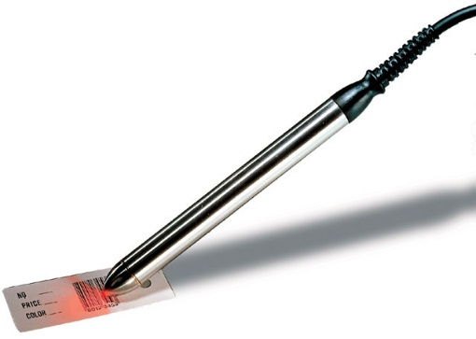

**Figure 2.11 Pen Type Reader** **(REF:** [**www.barcodesinc.com**](www.barcodesinc.com)**)**

1. Laser Scanner. Hand-held or stationary scanner, similarly to Pen-Type Reader but Laser Scanner uses a laser beam that have lenses to allow scanner to read the barcode regardless of orientation and can scan barcode up to 24 inches away

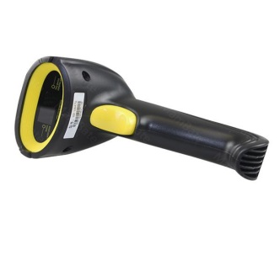

**Figure 2.12 Laser Scanner** **(REF:** [**www.aliexpress.com**](www.aliexpress.com)**)**

1. CCD (Charge-Coupled Device) Reader. Improvements Pen Wand, have better read-range and often used in retail sales that typically similarly gun type interface. Scan the barcode with range one inch from the barcode with several light sensor to scanning the barcode.

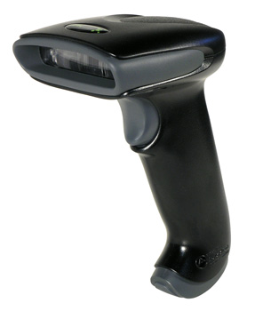

**Figure 2.13 CCD Reader** **(REF:** [**www.barodediscounters.com**](http://www.barodediscounters.com)**)**

1. Omni-Directional Barcode Scanner. The barcode reader that very efficient in decoding in badly printed, crumpled and even torn barcodes on product and highly advanced.

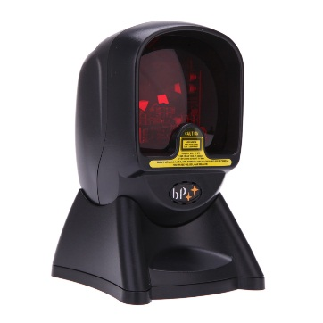

**Figure 2.14 Omni Directional Reader** **(REF:** [**www.aliexpress.com**](http://www.aliexpress.com)**)**

1. Slot Barcode Scanner. Stationary scanner typically used to scan barcode on identification cards, the item with the barcode its pulled by hand through the slot.

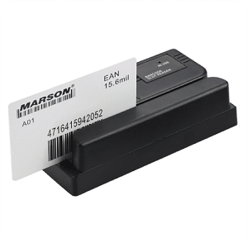

**Figure 2.15 Slot Reader** **(REF:** [**www.acesuppliers.com**](http://www.acesuppliers.com)**)**

1. Camera-Based Image Scanner. Installed with a camera and image processing techniques in reading barcodes. Using a small video camera to capture an image of a barcode and then using digital image processing techniques to decode the barcode advanced into the character. In use the camera as a linear barcode reader, the authors apply by using a barcode scanner app on android smartphone

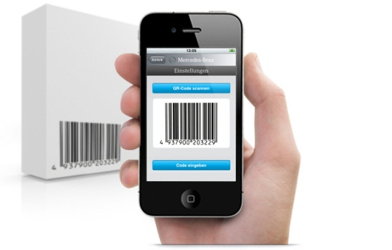

**Figure 2.16 Camera Based Reader (REF:** [**www.smartmobilefactory.com**](www.smartmobilefactory.com)**)**